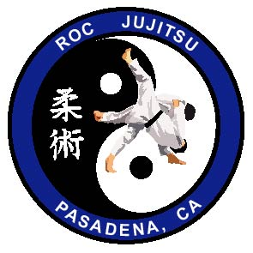Meaning of the R.O.C. Jujitsu Patch

The letters R.O.C. stand for Reynolds, Olympius, and Corona, the founders of the of the Villa Parke Jujitsu program. Therefore, the letters don’t necessarily represent the style of Jujitsu as much as the teaching philosophies of the three founders.
R.O.C. also represents some of the values learned in class: Respect, Obedience, Courage.
OR some of the things we need to overcome in our lives: Recklessness, Outrage, Cowardice.
What we attempt before using force: Reasoning, Outsmarting, Communicating.
What we do if force is necessary: Rush-in, Overpower, and Conquer.
What our instructors do in class: Reassure, Observe, and Challenge our students.
How you will feel after class: Remarkable, Outstanding, Confident.

The word Jujitsu is made up of two separate Japanese words: JU (gentle) and JITSU (art).

What do the Japanese letters stand for?
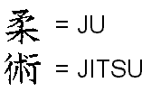The ying-yang  represents peace and harmony. It is also the symbol for peace, harmony, and balance in one’s chi.

The two figures in the middle are demonstrating a modified hip throw (o-goshi), a technique widely used in our class.

The colors of the patch: White represents the beginning rank belt color. Black represents the highest rank. The blue background represents tranquility, and was also added because in our system, black belts have the option of wearing a blue judo gi.

The circular shape of the patch, much like a wedding ring, represents eternity. Our study of the martial arts is ongoing and we continually strive to improve ourselves.

